SELF LEARNING BOT (MEDIC BOT)

**A PROJECT REPORT**

***Submitted by,***

## Mr. Ambrish Kumar. S - 20201CEI0001 Mr. Mohammed Enthihaj -20201CEI0011 Mr. Rihan Anwar C A - 20201CEI0030 Mr. Krishnan S - 20201CEI0077

***Under the guidance of,***

## Mr. MUTHURAJU V

***in partial fulfillment for the award of the degree of***

# BACHELOR OF TECHNOLOGY

**IN**

# COMPUTER ENGINEERING

**[Artificial Intelligence and Machine Learning]**

**At**



**PRESIDENCY UNIVERSITY BENGALURU JANUARY 2024**

**PRESIDENCY UNIVERSITY**

**SCHOOL OF COMPUTER SCIENCE AND ENGINEERING**

**CERTIFICATE**

This is to certify that the Project report **“Self-Learning Bot (Medic Bot)** being submitted by “Ambrish Kumar S, Mohammed Enthihaj, Rihan Anwar C A, Krishnan S” bearing roll number(s) “20201CEI0001 , 20201CEI0011, 20201CEI0030, 20201CEI0077 ” in partial fulfilment of requirement for the award of degree of Bachelor of Technology in Computer Engineering[Artificial Intelligence and Machine Learning] is a bonafide work carried out under my supervision.

**Muthu Raju V** Asst Professor School of CSE

Presidency University

**Dr. Gopal K. Shyam**

Professor & HoD School of CSE Presidency University

**Dr. C. KALAIARASAN**

Associate Dean School of CSE&IS Presidency University

**Dr. SHAKKEERA L**

Associate Dean School of CSE&IS Presidency University

**Dr. SAMEERUDDIN KHAN**

Dean School of CSE&IS Presidency University

# SCHOOL OF COMPUTER SCIENCE AND ENGINEERING

**DECLARATION**

We hereby declare that the work, which is being presented in the project report entitled **Self Learning Bot (Medic Bot)** in partial fulfilment for the award of Degree of **Bachelor of Technology** in **Computer Engineering [Artificial Intelligence and Machine Learning]**, is a record of our own investigations carried under the guidance of **Muthu Raju V, Asst Professor, School of Computer Science and Engineering, Presidency University, Bengaluru.**

We have not submitted the matter presented in this report anywhere for the award of any other Degree.

|  |  |  |
| --- | --- | --- |
| **NAME OF THE STUDENT** | **ROLL Number** | **Signature’s** |
| **AMBRISH KUMAR S** | **20201CEI0001** |  |
| **MOHAMMED ENTHIHAJ** | **20201CEI0011** |  |
| **RIHAN ANWAR CA** | **20201CEI0030** |  |
| **KRISHNAN S** | **20201CEI0077** |  |

# ABSTRACT

In the field of healthcare innovation, our team has developed a Medic Bot, seamlessly integrating Reinforcement Learning and Natural Language Processing (NLP) to enhance the user experience in medical assistance. This innovative system is designed to provide users with an interactive and personalized healthcare platform, allowing them to engage in meaningful conversations, seek medical guidance, and receive tailored recommendations. Through the application of Reinforcement Learning, the Medic Bot continually refines its responses based on user feedback and interactions, ensuring a dynamic learning process that adapts to evolving user needs. Natural Language Processing forms the foundation of the Medic Bot's ability to comprehend and respond to user queries with human-like understanding, creating a more intuitive and accessible interaction. The system incorporates advanced machine learning algorithms to classify intents, extract key medical entities, and generate responses that align with the intricacies of natural language. By navigating through medical literature, research papers, and clinical notes, the Medic Bot establishes a robust knowledge base, providing users with accurate and relevant medical information. This inventive fusion of Reinforcement Learning and NLP not only represents a significant advancement in healthcare technology but also emphasizes continuous learning and improvement. The Medic Bot's capacity to learn from user feedback, coupled with its commitment to staying informed through iterative development, positions it as a dynamic and reliable healthcare companion.

**Keywords— NLP, Reinforcement Learning, KNN, TF-IDF, SVM, cosine similarity, deep learning**

First of all, we indebted to the **GOD ALMIGHTY** for giving me an opportunity to excel in our efforts to complete this project on time.

**ACKNOWLEDGEMENT**

We express our sincere thanks to our respected dean **Dr. Md. Sameeruddin Khan**, Dean, School of Computer Science and Engineering & School of Information Science, Presidency University for getting us permission to undergo the project.

We record our heartfelt gratitude to our beloved Associate Deans **Dr. Kalaiarasan C and Dr. Shakkeera L,** School of Computer Science and Engineering & School of Information Science, Presidency University and **Dr. Gopal K. Shyam**, Head of the Computer Engineering., School of Computer Science and Engineering, Presidency University for rendering timely help for the successful completion of this project.

We are greatly indebted to our guide **Mr. Muthuraju V, Assistant Professor**, School of Computer Science and Engineering, Presidency University for her inspirational guidance, and valuable suggestions and for providing us a chance to express our technical capabilities in every respect for the completion of the project work.

We would like to convey our gratitude and heartfelt thanks to the University Project-II Coordinators **Dr. Sanjeev P Kaulgud, Dr. Mrutyunjaya MS** and also the department Project Coordinators **Dr. Sasidhar Babu S., Dr. Sudha P., and Ms. Yogeetha B. R.**

We thank our family and friends for the strong support and inspiration they have provided us in bringing out this project.

**Ambrish Kumar S Mohammed Enthihaj Rihan Anwar C A Krishnan S**

**LIST OF TABLES**

|  |  |  |  |
| --- | --- | --- | --- |
| **Sl. No.** | **Table Name** | **Table Caption** | **Page No.** |
| 1 | Table 7.1 | Gantt Chart | 19 |

**LIST OF FIGURES**

|  |  |  |  |
| --- | --- | --- | --- |
| **Sl. No.** | **Figure** | **Caption** | **Page No.** |
| 1 | Figure 4 | Methodology | 7 |
| 2 | Figure 6.1 | Use case Diagram | 12 |
| 3 | Figure 6.2 | Class Diagram | 13 |
| 4 | Figure 6.3 | Sequence Diagram | 13 |
| 5 | Figure 6.4 | Collaboration Diagram | 14 |
| 6 | Figure 6.5 | Deployment Diagram | 14 |
| 7 | Figure 6.6 | Activity Diagram | 15 |
| 8 | Figure 6.7 | Component Diagram | 16 |
| 9 | Figure 6.8 | ER Diagram | 16 |
| 10 | Figure 6.9 | Zero Level | 17 |
| 11 | Figure 6.10 | Level 1 | 17 |
| 12 | Figure 6.11 | Level 2 | 18 |
| 13 | Figure 9.1 | Result1 | 23 |
| 14 | Figure 9.2 | Result2 | 23 |
| 15 | Figure 11.1 | Home Page | 29 |
| 16 | Figure 11.2 | Register Page | 29 |
| 17 | Figure 11.3 | Login Page | 29 |
| 18 | Figure 11.4 | About Page | 30 |
| 19 | Figure 11.5 | Info Page | 30 |
| 20 | Figure 11.6 | Upload Page | 30 |
| 21 | Figure 11.7 | Result Page | 31 |

**TABLE OF CONTENTS**

Abstract i

Acknowledgement ii

CHAPTER 01 1

* 1. Introduction 1
  2. Motivation 1
  3. Problem Statement 2
  4. Project Introduction 3

CHAPTER 02 4

* 1. Literature Survey 4
  2. Related Work 4
     1. Work1 5
     2. Work2 6
     3. Work3 7
     4. Work4 7
     5. Work5 7

CHAPTER 03 8

* 1. RESEARCH GAPS OF EXISTING METHODS 8
     1. Existing System 8
     2. Gaps in The System 8

CHAPTER 04 10

* 1. Proposed Methodology 10
     1. Data Collection and Preparation 11
     2. Natural Language Processing 11
     3. Machine Learning Deep Learning 12
     4. Reinforcement Learning and Feedback Loop 13
     5. Iterative Development and Evaluation 13

**CHAPTER 05 14**

* 1. Objectives 14

CHAPTER 06 15

* 1. System Design And Implementation 15
     1. Introduction of Input Design 16
     2. Output Design 17
     3. UML Diagram 17
     4. Use Case Diagram 18
     5. Class Diagram 19
     6. Sequence Diagram 20
     7. Collaboration Diagram 21
     8. Deployment Diagram 21
     9. Activity Diagram 22
     10. Component Diagram 23
     11. ER Diagram 24
     12. DFD Diagram 25

CHAPTER 07 26

* 1. Timeline For Execution Of Project 26

CHAPTER 08 27

* 1. Outcomes 27

CHAPTER 09 29

* 1. Results and Discussions 29
     1. Modules 29
     2. System 30
     3. User 31
     4. Results 32

CHAPTER 10 33

* 1. Conclusion 33

CHAPTER 11 34

* 1. References 34

APPENDIX - A 36

* 1. Pseudocode 36

APPENDIX - B 37

* 1. Screenshots 37

APPENDIX - C 39

* 1. Enclosures 39

# CHAPTER-1 INTRODUCTION

## Motivation

The motivation for Exploring into the subject of "Self-Learning Bot In Medic Sector" arises from the pressing need for inventive solutions to tackle the challenges confronted by the healthcare industry. The surge in demand for healthcare services contrasts with a simultaneous decline in the number of available doctors, creating a noticeable gap that calls for exploration of alternative methods to deliver prompt and effective assistance to patients. Chatbots, driven by Natural Language Processing (NLP), emerge as a promising solution to bridge this gap, providing a scalable and accessible means of interaction, especially for the elderly. The motivation is grounded in the aspiration to harness the potential of these technologies for improving patient care, disseminating essential health information, and streamlining healthcare processes. Furthermore, the integration of machine learning algorithms, such as KNN for symptom analysis, introduces possibilities for precise and efficient evaluation, contributing to the overall enhancement of healthcare services.

## Problem Statement

The healthcare sector grapples with challenges such as limited resources, time constraints, and a scarcity of medical professionals, resulting in delays in delivering medical advice, disseminating health information, and addressing diverse patient needs. The problem statement revolves around the quest for innovative solutions to these challenges through the strategic implementation of chatbots and NLP technology. Recognizing the inefficiencies in traditional healthcare systems, there is a call for a paradigm

shift towards automated and intelligent systems. The problem statement underscores the importance of data collection, feature extraction, and system testing in ensuring the effectiveness and reliability of NLP-powered chatbots. Additionally, the complexity of the task at hand is emphasized by the need for seamless integration of machine learning algorithms and external APIs.

## Project Introduction

The topic "Self-Learning Bot in the Medical Sector" explores the application of chatbots and natural language processing (NLP) in healthcare. It delves into the creation of conversational chatbots designed to engage with elderly individuals, track health trends, and deliver fundamental health information. The document discusses the incorporation of machine learning algorithms, specifically KNN, for evaluating symptoms and the integration of external APIs to enhance NLP capabilities. It emphasizes the pivotal role of these technologies in automating user communication and providing crucial health information. Furthermore, the topic explains on the processes of data collection, feature extraction, and system testing. It also highlights the potential of chatbots to streamline healthcare processes, saving both time and money also underscores the broad and optimal experiences that chatbots can offer across diverse applications. It ultimately emphasizes the transformative impact of NLP-powered chatbots on the medical sector, enhancing patient care and accessibility to vital medical information. The use of chatbots and natural language processing (NLP) in healthcare has received great attention in recent years. With the demand for healthcare services increasing and the number of doctors decreasing, chatbots have emerged as a promising way to provide advice and assistance to patients.

These chatbots can interact with patients by analyzing their symptoms, and provide appropriate medical advice. The "Active language bots in healthcare" provides information on the development and use of chatbots in

healthcare. The article also introduces machine learning algorithms such as KNN for symptom analysis and integration of NLP external APIs. Additionally, the article highlights the importance of collecting data and disseminating results in the development of effective chatbots. It also discusses software and database testing procedures and backup procedures. Aside from chatbots' benefits in saving clinical time and money, their ability to deliver comprehensive information and insights across multiple applications is also important. Overall, this article provides insight into the development and use of chatbots in healthcare and highlights the role NLP- powered chatbots can play to support patient care and access to medical information. healthcare Industry.

* 1. **Related Work**

# CHAPTER-2 LITERATURE SURVEY

## Advance Health-Care Chatbot Using Python:

*S Santhosham & Chitranjan Prasad Sah*

*CSE-APEX, Chandigarh University Gharuan, Mohali, Panjab, India* The advanced Healthcare Chat Bot the using Python discusses the improvement of a medical chatbot powered through artificial intelligence. It utilizes natural Language Processing (NLP) to talk with users, identify health troubles, provide information on illnesses, and advise users to a medical doctor for further treatment. The chatbot can be mounted on websites or in apps, supplying a flexible and green healthcare assistance solution.

## Artificial Intelligence based Healthcare Chat Bot System:

*Akash Goel, Satyam & Shubham Sharma*

*Computer Science, KIET Group of Institutions, Ghaziabad, India.* The "Artificial Intelligence based Healthcare Chat Bot " discusses the development of a healthcare chat bot the usage of synthetic Intelligence (AI) to assist in presenting simple fitness statistics to customers earlier than contacting a medical doctor, specifically for minor health troubles. The chat bot device employs AI and gadget gaining knowledge of to retrieve person queries from a database and offer accurate responses. It ambitions to save healthcare prices and boom scientific expertise. The file additionally highlights the potential for future enhancements, together with schooling the chat bot the usage of system gaining knowledge of algorithms to beautify accuracy

and responsiveness. additionally, it emphasizes the accessibility and round-the-clock availability of the chat bot. The device's technique, interface, and conversation examples also are presented, showcasing the ability blessings of integrating AI-based totally chat bots inside the healthcare sector. The references supplied within the report aid the studies and improvement of AI-based totally chat bot systems in healthcare.

\

## Conversational Bot for Pharmacy: A Natural Language Approach

*Nur Syahirah Ahmad, Mohd Hamim Sanusi, Mohd Helmy Abd Wahab, Zainal Abidin Sayadi, Aida Mustapha & Mohd Zain Uri Saringat Faculty of Computer Science and Information Technology, University Tun Hussein Onn Malaysia, Parit Raja, 86400 Batu Pahat, Johor,*

*Malaysia*

“Engaging Pharmacies: An Effective Conversational Approach,” discusses the development of a pharmacy chatbot application by Sharifah Nur. Authors Nur Syahirah Ahmad and Mohd Hamim Sanusi explain the process of chatbot design, testing, and user acceptance. The goal is to provide information about vaccines and improve the overall customer experience. The authors also compared the developed system with existing applications in the medical field to determine its advantages and disadvantages. The chatbot was tested for functionality and user acceptance, and the results showed that it met users' needs and improved the process of sending medication information. The article concludes by touching on future work in this field.

## Automatized Medical Chatbot (Medibot):

*Prakhar Srivastava & Nishant Singh*

*Computer Engineering and Application GLA University Mathura, India*

The development of a medical chatbot (Medibot) designed to communicate with patients and provide personalized diagnoses based on the patient's symptoms and profile. This chatbot system can identify symptoms from user input with a 65% accuracy rate and provide patients with more accurate information through simple symptom description and conversation. The article also compares different methods for diagnosis; SVM shows higher accuracy compared to KNN and Naive. Additionally, plans to improve chatbot performance by combining visual and analytical capabilities are outlined in the future work section. Feedback from testers showed that the chatbot was well controlled and was able to understand and implement ideas clearly. Users find the robot easy and effective to use, which demonstrates its effectiveness in treatment.

## Deployment of Medibot in Medical Field

*P. Reshmanth, P. Sushanth Chowdary, Yogitha. R & R. Aishwarya Department of Computer Science and Engineering Sathyabama Institute of Science and technology*

Natural Language Processing (NLP) plays a pivotal role in advancing human productivity, offering various opportunities like virtual assistants, chatbots, spam detection, transcription, and machine translation. One notable tool in this domain is the Natural Language

Toolkit (NLTK), a Python library facilitating the creation of programs understanding human language. NLTK encompasses functions for sentence generation, tokenization, semantic reasoning, and inference extraction from text. In the context of neural networks, the array model signifies the storage of Kera’s layers, with data flowing through each layer until reaching the output layer, connecting these layers typically through neural networks.

NLP activities frequently involve deep learning, with Recurrent Neural Networks (RNNs) being an example. Numerous research papers and articles, including those on AI medical chatbots, UMLS- based chatbots, and deep learning applications in healthcare, have been published. A particular focus has been on Medibot, a chatbot designed using an ontology-based approach for collecting drug information and price comparison. This bot follows standard doctor interactions, leveraging visualizations and demonstrating the potential for enhancing healthcare through innovative technologies.

## Nurse-Bot: A Robot System Applied to Medical Assistance

The paper "Nurse-Bot: A Robot System Applied to Medical Assistance" introduces a mechatronics system designed for providing care to the elderly and individuals with medical needs. This robotic system acts as a nurse-like assistant, monitoring vital signs and managing medical information to support both patients and healthcare providers. The paper underscores the significance of tackling challenges in healthcare, especially in situations where there is a shortage of human resources.

The experimental results presented in the paper showcase the capabilities of Nurse-Bot, including monitoring vital signs, dispensing

medications, and facilitating mobility within a designated area. The paper also discusses the potential of Nurse-Bot to enhance the quality of care and improve treatment outcomes for those requiring medical assistance.

Overall, the paper underscores the pivotal role of mechatronics and robotics in addressing healthcare challenges and improving the interaction between humans and technology.

## E-Health Bot to change the Face of Medicare

The paper titled "E-Health Bot to change the Face of Medicare" explores the application of chatbots in the healthcare industry and their potential to transform the dynamics of interactions with healthcare providers. The document delves into the underlying principles of Artificial Intelligence that govern chatbot functionality, including Natural Language Processing (NLP), Sentiment Analysis, Tokenization, Named Entity Recognition, Normalization, and Dependency Parsing.

Furthermore, it outlines the development and utilization of a specific chatbot named Medicbot, designed to assist individuals with their medical inquiries. The chatbot features a personal assistant named Medico, which engages with users and provides appropriate responses to their queries. In conclusion, the paper examines the potential advantages and limitations associated with the integration of chatbots in Medicare, such as enhanced communication, increased engagement, and improved emergency services.

# CHAPTER-3

**RESEARCH GAPS OF EXISTING METHODS**

## Existing System

In the existing methods creating a self-learning medical bot involves challenges such as ensuring unbiased and high-quality training data, meeting stringent regulatory standards, addressing legal and ethical concerns, and managing continuous learning while avoiding errors. The need for interpretability, effective user communication, and seamless integration into healthcare systems adds complexity. Balancing uncertainty, cybersecurity, and fostering collaboration with healthcare professionals are also critical considerations in developing a reliable and ethical medical bot.

## Gaps in the system

**Data Limitations:** Incomplete or inadequate datasets can lead to gaps in the bot's knowledge, affecting its ability to handle a diverse range of medical scenarios.

**Lack of Real-time Data Integration:** The absence of real-time patient data or access to emerging medical research can limit the bot's ability to provide the most current and relevant information.

**Inability to Handle Uncertainty**: Gaps in managing uncertainty may result in the bot providing overly confident or inaccurate diagnoses, affecting user confidence.

**Time consuming:** Every work is done manually so we cannot generate report in the middle of the session or as per the requirement because it is very time consuming.

**Privacy and Security Gaps:** Issues related to data privacy and security may create gaps in safeguarding sensitive patient information, raising concerns among users and healthcare providers.

# CHAPTER-4 PROPOSED MOTHODOLOGY

In the existing methods creating a self-learning medical bot involves challenges such as ensuring unbiased and high-quality training data, meeting stringent regulatory standards, addressing legal and ethical concerns, and managing continuous learning while avoiding errors. To overcome this accuracy issues, we go for the proposed system.

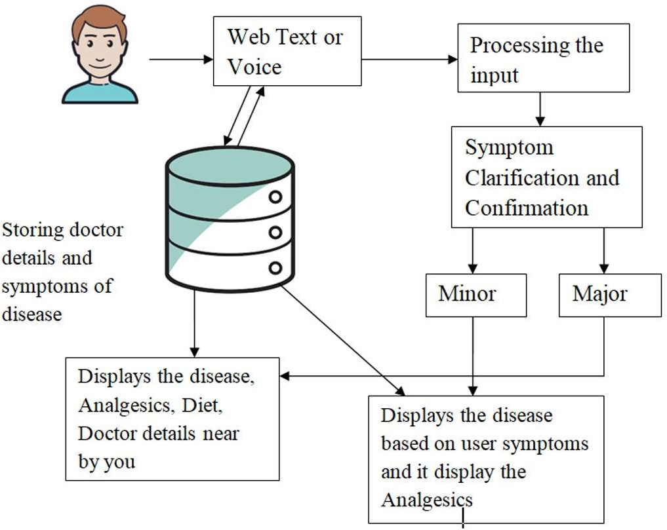

**Fig 4. Proposed Method**

* 1. **Data Collection and Preparation**: Collect a diverse dataset comprising medical literature, research papers, clinical notes, and publicly available healthcare information to establish the foundational knowledge of the chatbot. Preprocess the data through cleaning and standardizing the text. Remove irrelevant information and structure the data in a format suitable for analysis and

modelling.

* 1. **Natural Language Processing (NLP):** Implement NLP techniques for parsing and comprehending medical text. This includes tokenization, stop-word removal, stemming, and lemmatization. Utilize named entity recognition (NER) and part-of speech tagging to identify medical entities, relationships, and categories within the text.
  2. **Machine Learning and Deep Learning Models:** Develop machine learning models, such as support vector machines (SVM) or decision trees, to classify intents and extract key medical entities from user queries. Explore advanced deep learning models like recurrent neural networks (RNNs) or transformers for intent classification, entity recognition, and response generation based on pre- processed medical text.
  3. **Reinforcement Learning and Feedback Loop:** Implement a reinforcement learning approach to continually enhance the chatbot's responses based on user feedback and interactions. Create a feedback loop enabling users to rate and provide feedback on the chatbot's responses. This allows the model to learn from mistakes, improving its accuracy and relevance over time.
  4. **Iterative Development and Evaluation:** Adopt an iterative development approach, continuously updating, refining, and expanding the chatbot with new medical data and improved algorithms. Evaluate the chatbot's performance using metrics like precision, recall, F1-score, and user satisfaction surveys. Identify areas for enhancement to ensure the chatbot meets its intended objectives

# CHAPTER-5 OBJECTIVES

The objective of the project is to develop,

1. **Enhanced Diagnostic Accuracy:** Improve the medic bot's ability to accurately diagnose medical conditions by implementing self-learning mechanisms that continuously adapt and evolve based on new medical information and case outcomes.
2. **User-Friendly Interaction:** Develop an intuitive and user-friendly interface that ensures effective communication between the self-learning medic bot and users, catering to diverse levels of medical knowledge and providing clear explanations for diagnoses and recommendations.
3. **Privacy and Security Compliance:** Implement robust privacy and security measures to ensure compliance with healthcare regulations and protect sensitive patient data, fostering trust among users and healthcare providers in the use of the self-learning medic bot.
4. **Continuous Learning and Adaptation:** Establish mechanisms for the self- learning medic bot to continuously learn from real-world medical cases, emerging research, and user feedback. Enable the bot to adapt its knowledge base to stay current and relevant in the rapidly evolving field of medicine.
5. **Integration with Healthcare Systems:** Facilitate seamless integration of the self-learning medic bot with existing healthcare systems, electronic health records (EHRs), and medical workflows to enhance collaboration between the bot and healthcare professionals, ensuring a more cohesive and efficient healthcare delivery process.

# CHAPTER-6

**SYSTEM DESIGN & IMPLEMENTATION**

* 1. **Introduction of Input Design**

The proposed objectives for the chatbot system are:-

* + 1. Delivering a personalized and interactive healthcare experience that allows users to ask questions and receive relevant medical information and recommendations from the chatbot.
    2. Leveraging natural language processing (NLP) and machine learning algorithms to comprehend natural language, facilitating automated user communication.
    3. Integrating external APIs for NLP to analyse texts, revealing sentence structure, and providing details about unique words.
    4. Incorporating a knowledge base to organize user queries, cross-referencing them with the chatbot's knowledge base.
    5. Utilizing mechanisms like TF-IDF, cosine similarity, and N-gram similarity to asses keyword ranking and sentence similarity.
    6. Implementing the system using the Java programming language to create various interfaces.
    7. Employing a Relational Database Management System (RDBMS) to store input query information for communication patterns.
    8. Empowering elderly patients to monitor blood pressure trends and receive warnings or healthcare advice from the chatbot to prevent or alleviate certain diseases.
    9. Offering a comprehensive healthcare experience by combining sentence structuring capabilities, a chat manager, knowledge base, and metaphysics component with external APIs.
    10. Stressing the significance of data collection and feature extraction in the development of effective chatbots, ensuring the reliability and accuracy of the chatbot’s responses.
  1. **Output Design**

The design of output is the most important task of any system. During output design, developers identify the type of outputs needed, and consider the necessary output controls and prototype report layouts D.

Objectives for Output Design

* + 1. Incorporates natural language processing (NLP) and machine learning algorithms to comprehend user queries effectively.
    2. Delivers conversational and personalized responses that simulate interactions with a genuine physician.
    3. Organizes user queries by leveraging a knowledge base and cross- referencing them with the chatbot's extensive knowledge repository.
    4. Utilizes sophisticated mechanisms like TF-IDF, cosine similarity, and N- gram similarity to assess keyword ranking and sentence similarity for enhanced accuracy.
    5. Presents responses in a user-friendly interface, encompassing text, images, or links to external resources for a comprehensive user experience.
    6. Leverages external APIs for NLP to meticulously parse texts, revealing sentence structures, and providing insights into unique words.
    7. Offers follow-up questions or suggestions based on the user's responses, fostering a more personalized and interactive healthcare experience.
  1. **UML Diagrams**
     1. **Use Case Diagram**

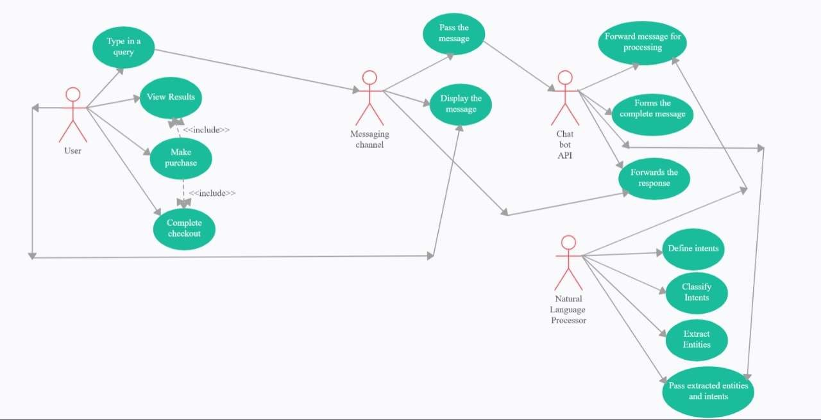A use case diagram in the Unified Modeling Language (UML) is a type of behavioral diagram defined by and created from a Use-case analysis. Its purpose is to present a graphical overview of the functionality provided by a system in terms of actors, their goals (represented as use cases), and any dependencies between those use cases. The main purpose of a use case diagram is to show what system functions are performed for which actor. Roles of the actors in the system can be depicted.

**Figure 6.1. Use case Diagram**

* + 1. **Class Diagram**

In software engineering, a class diagram in the Unified Modelling Language (UML) is a type of static structure diagram that describes the structure of a

system by showing the system's classes, their attributes, operations (or methods), and the relationships among the classes. It explains which class contains information.

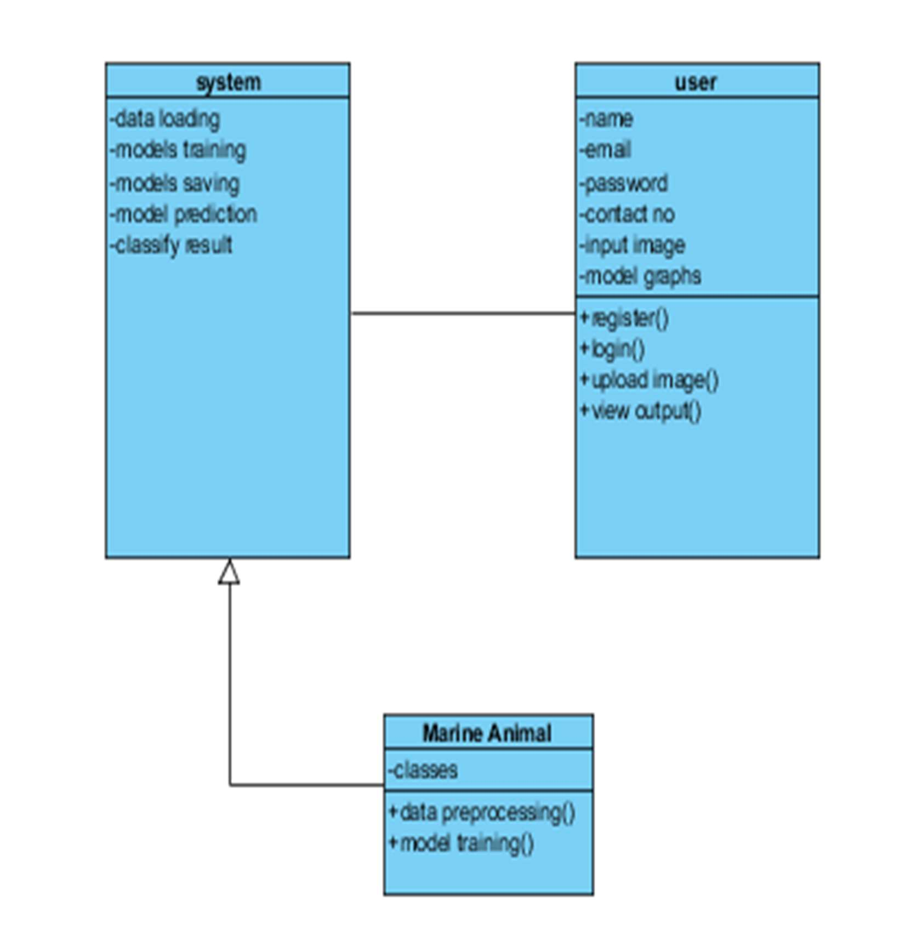

**Figure 6.2.Class Diagram**

* + 1. **Sequence Diagram**

A sequence diagram in Unified Modelling Language (UML) is a kind of interaction diagram that shows how processes operate with one another and in what order. It is a construct of a Message Sequence Chart. Sequence diagrams are sometimes called event diagrams, event scenarios, and timing diagrams.

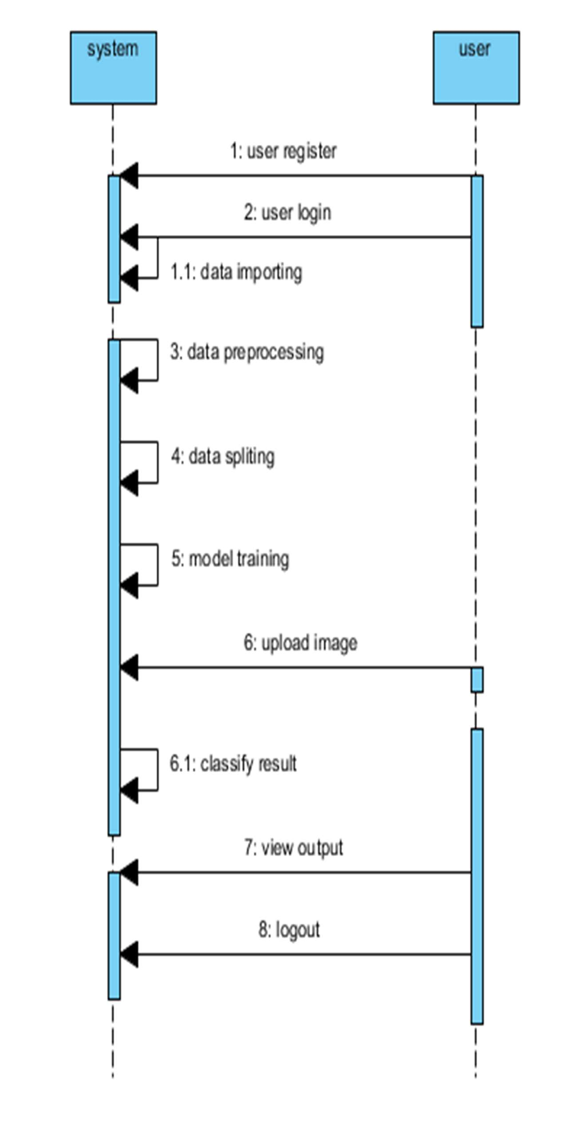

**Figure 6.3. Sequence Diagram**

* + 1. **Collaboration Diagram**

In collaboration diagram the method call sequence is indicated by some numbering technique as shown below. The number indicates how the methods are called one after another. We have taken the same order management system to describe the collaboration diagram. The method calls are similar to that of a sequence diagram. But the difference is that the sequence diagram does not describe the object organization whereas the collaboration diagram shows the object organization.

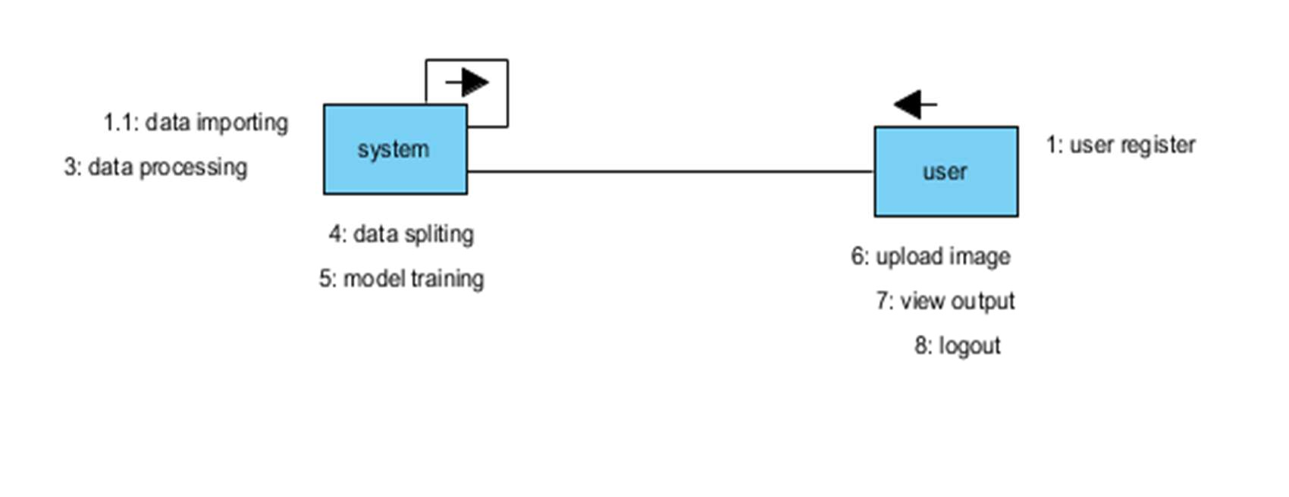

**Figure 6.4. Collaboration Diagram**

* + 1. **Deployment Diagram**

Deployment diagram represents the deployment view of a system. It is related to the component diagram. Because the components are deployed using the deployment diagrams. A deployment diagram consists of nodes. Nodes are nothing but physical hardware’s used to deploy the application.

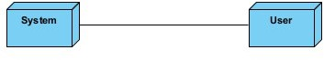

**Figure 6.5 Deployment Diagram**

* + 1. **Activity Diagram**

Activity diagrams are graphical representations of workflows of stepwise activities and actions with support for choice, iteration and concurrency. In the Unified Modelling Language, activity diagrams can be used to describe the business and operational step-by-step workflows of components in a system. An activity diagram shows the overall flow of control.

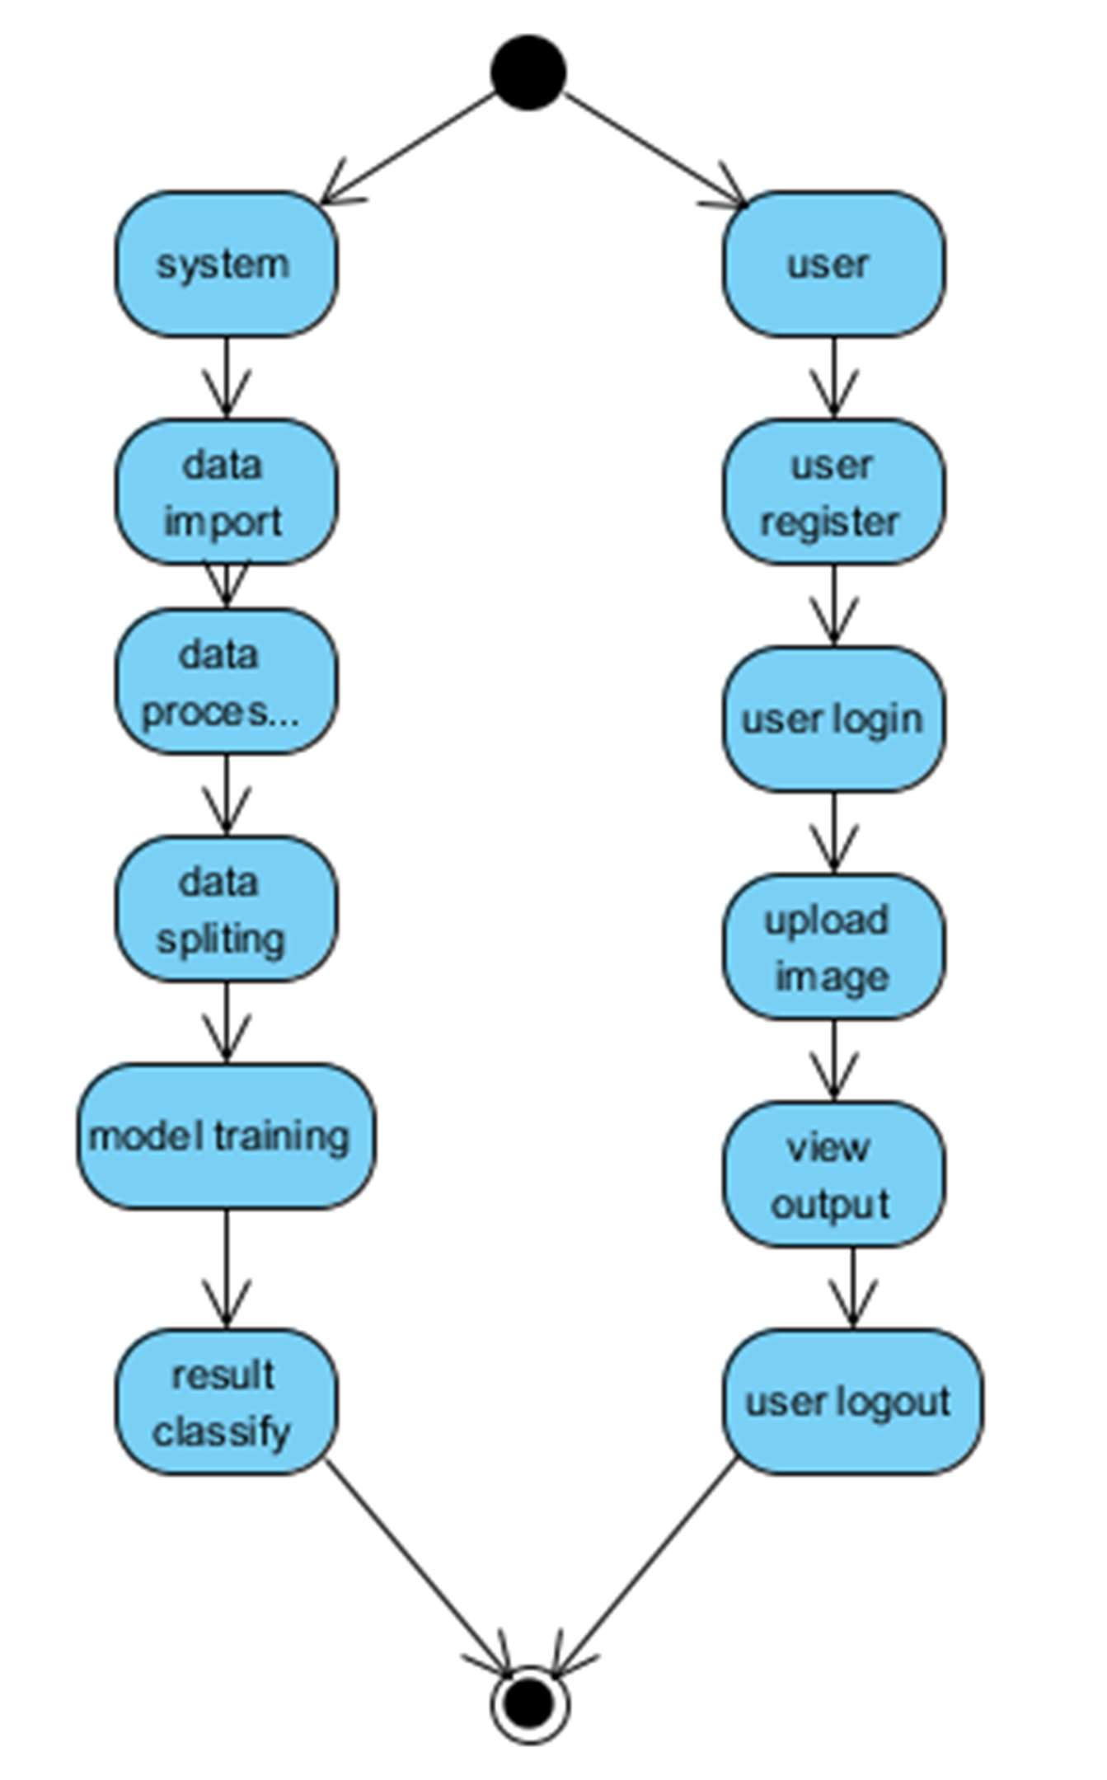

**Figure 6.6. Activity Diagram**

* + 1. **Component Diagram**

A component diagram, also known as a UML component diagram, describes the organization and wiring of the physical **c**omponents in a system. Component

diagrams are often drawn to help model implementation details and double- check that every aspect of the system's required functions is covered by planned development.

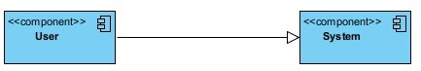

**Figure 6.7. Component Diagram**

* + 1. **ER Diagram**

An Entity–relationship model (ER model) describes the structure of a database with the help of a diagram, which is known as Entity Relationship Diagram (ER Diagram). An ER model is a design or blueprint of a database that can later be implemented as a database. The main components of E-R model are: entity set and relationship set.

An ER diagram shows the relationship among entity sets. An entity set is a group of similar entities and these entities can have attributes. In terms of DBMS, an entity is a table or attribute of a table in database, so by showing relationship among tables and their attributes, ER diagram shows the complete logical structure of a database. Let’s have a look at a simple ER diagram to understand this concept.

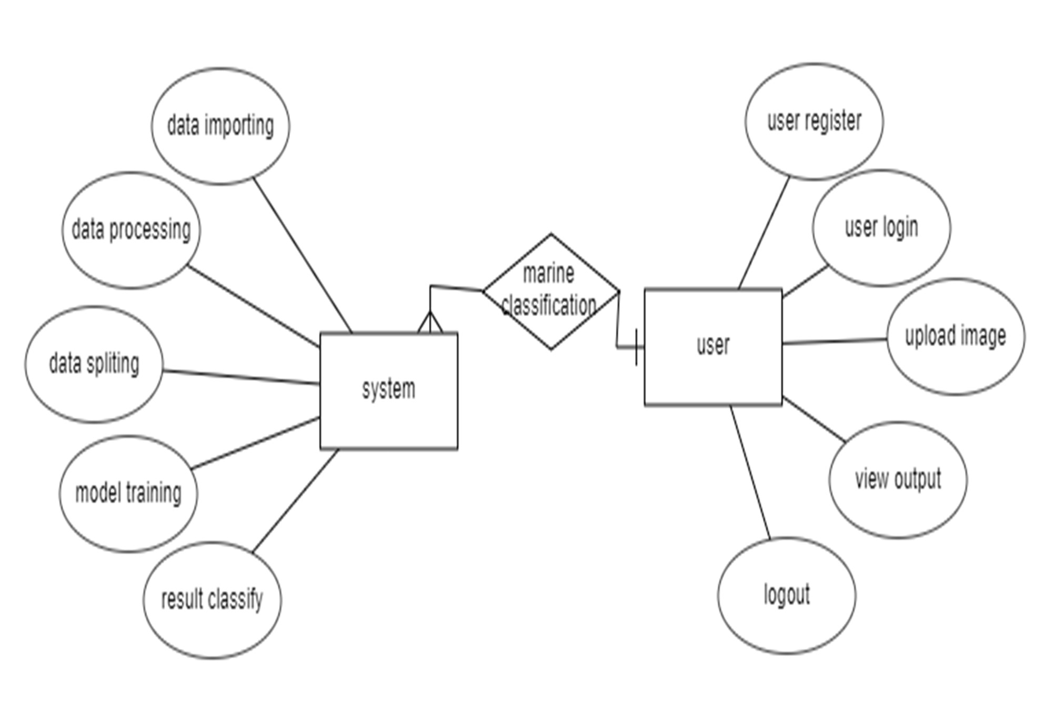

**Figure 6.8.ER diagram**

* 1. **DFD Diagram**

A Data Flow Diagram (DFD) is a traditional way to visualize the information flows within a system. A neat and clear DFD can depict a good amount of the system requirements graphically. It can be manual, automated, or a combination of both. It shows how information enters and leaves the system, what changes the information and where information is stored. The purpose of a DFD is to show the scope and boundaries of a system as a whole. It may be used as a communications tool between a systems analyst and any person who plays a part in the system that acts as the starting point for redesigning a system.

**Zero level Diagram**

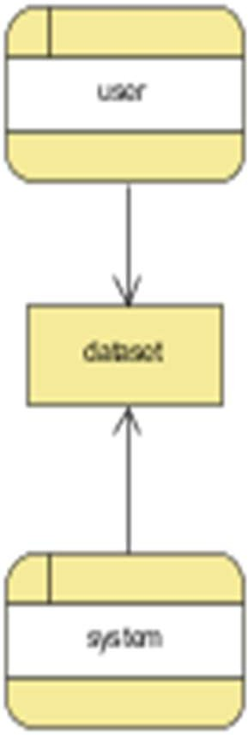

**Figure 6.9.Zero Level**

**Level 1 Diagram**

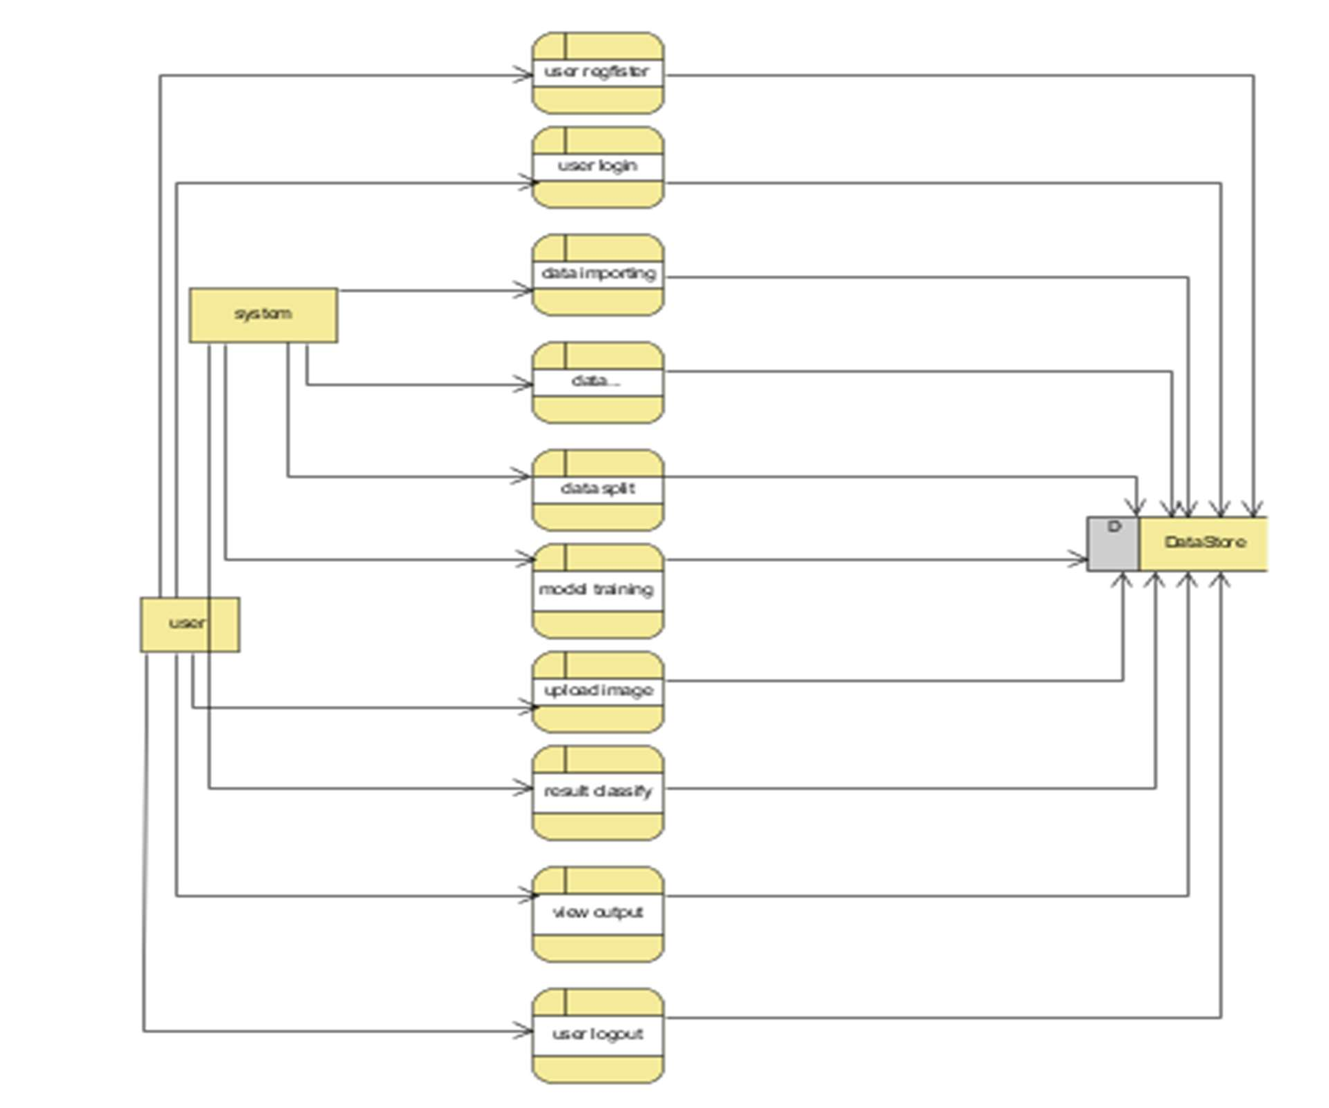

**Figure 6.10.Level 1**

**Level 2 Diagram**

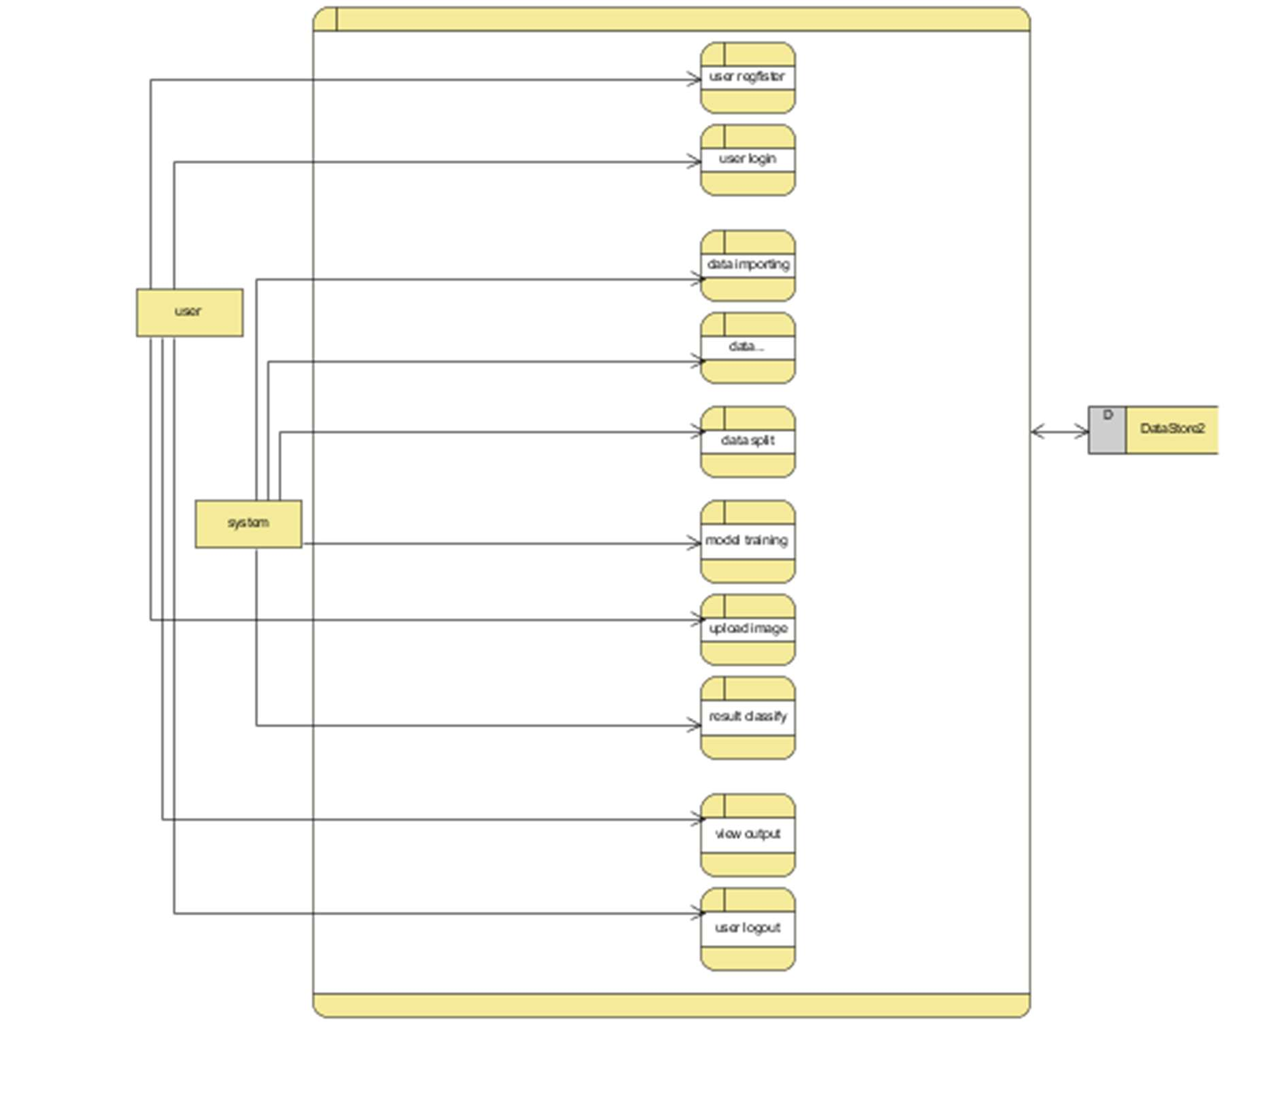

**Figure 6.11.Level 2**

**CHAPTER-7**

**TIMELINE FOR EXECUTION OF PROJECT**

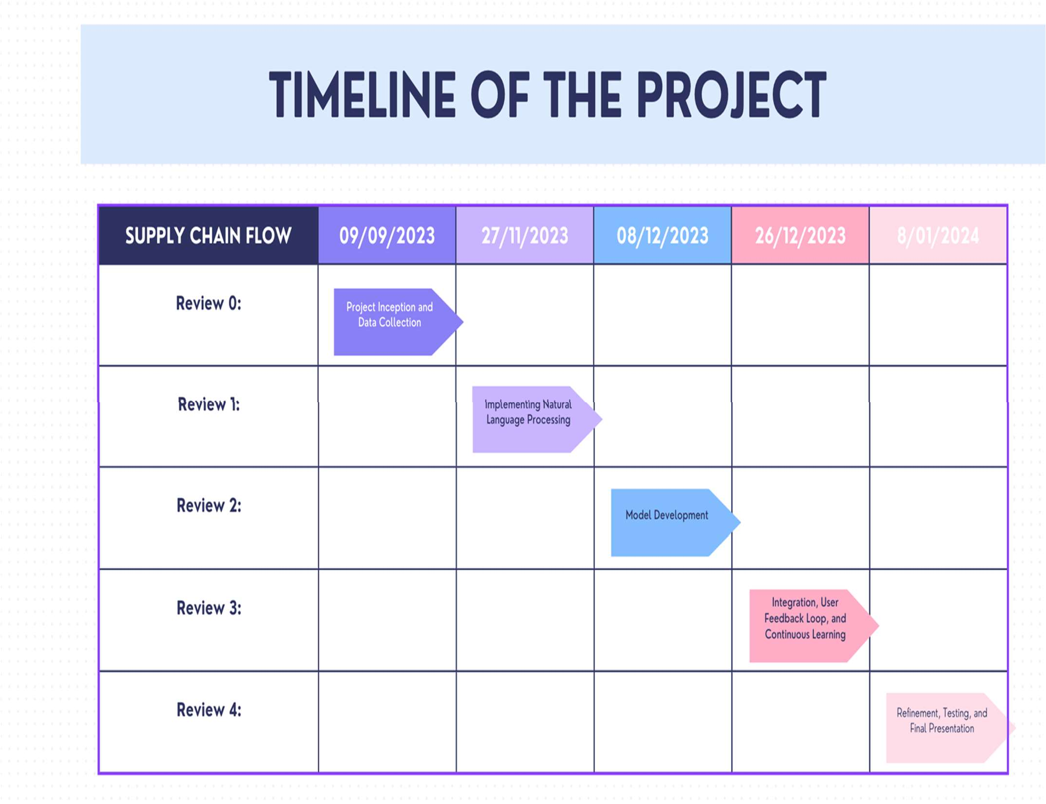

**CHAPTER-8 OUTCOMES**

**Improved Diagnostic Accuracy:**

Self-learning medic-bot continuously refine their diagnostic capabilities, leading to increased accuracy in identifying medical conditions based on user symptoms.

**Personalized Healthcare Recommendations:**

By learning from user profiles and medical histories, self-learning medicbots can provide personalized recommendations and interventions tailored to individual health needs.

**Enhanced User Interaction:**

Continuous learning enables medic-bot to understand and respond to user queries more effectively, creating a more engaging and user-friendly interaction.

**Adaptation to New Medical Knowledge:**

Medic-bot can stay up-to-date with the latest medical information, research findings, and treatment protocols, ensuring that they provide relevant and current information to users.

**Efficient Triage and Resource Optimization:**

Self-learning medicbots can assist in triaging patients, optimizing healthcare resources by providing initial assessments and recommendations, potentially reducing the burden on healthcare facilities.

**Increased User Trust:**

As the medic Bot demonstrates improved accuracy and adapts to evolving healthcare knowledge, users are likely to develop increased trust in the bot's recommendations and insights**.**

**Support for Healthcare Professionals:**

Medic-bot can assist healthcare professionals by quickly providing information, suggesting possible diagnoses, and staying updated on the latest medical research, thus supporting decision-making in healthcare settings.

**Continuous Improvement:**

Through ongoing learning from user interactions and feedback, self-learning medicbots can identify areas for improvement and adapt their models to enhance overall performance**.**

**Time and Cost Savings:**

Efficient and accurate preliminary assessments by self-learning medicbots can lead to time and cost savings in healthcare, streamlining the diagnostic process and optimizing resource utilization.

**Expanded Accessibility to Healthcare Information:**

Medicbots can provide healthcare information and initial assessments to a broader audience, potentially improving accessibility to healthcare insights, especially in areas with limited access to medical professionals.

It's essential to note that the specific outcomes will depend on the goals and scope of the project, the quality of data used for training the deep learning models, and the effectiveness of the chosen algorithms. For the latest information on this specific project, you may want to check recent publications, conference proceedings, or the project's official documentation.

* 1. **MODULES**
     1. **System**

# CHAPTER-9 RESULTS AND DISCUSSIONS

**Natural Language Processing (NLP):**

Implements NLP for user input understanding using tokenization and semantic analysis.

**Machine Learning Models:**

Incorporates models for learning from data, predicting diseases, and continuous improvement.

**Chatbot Interaction Module:**

Manages user interactions, interprets queries, and maintains conversation context.

**Security and Privacy:**

Ensures data security, encryption, and compliance with healthcare privacy regulations.

**Continuous Learning and Adaptation:**

Enables the bot to adapt to new medical information and updates machine learning models for enhanced diagnostic accuracy.

**9.1.2. User**

**User registration:**

User can register with the mentioned details like name, email, password, confirm password, contact number.

**User login:**

In this page user can login with the email and password for further process

**Upload Image:**

The user needs to ask about disease, which needs to be classified.

**View Results:**

User views the classified image results.

**Logout:**

After complete the process user can logout from the process

* 1. **Results**

**Result page:** Here predicted output will see the user

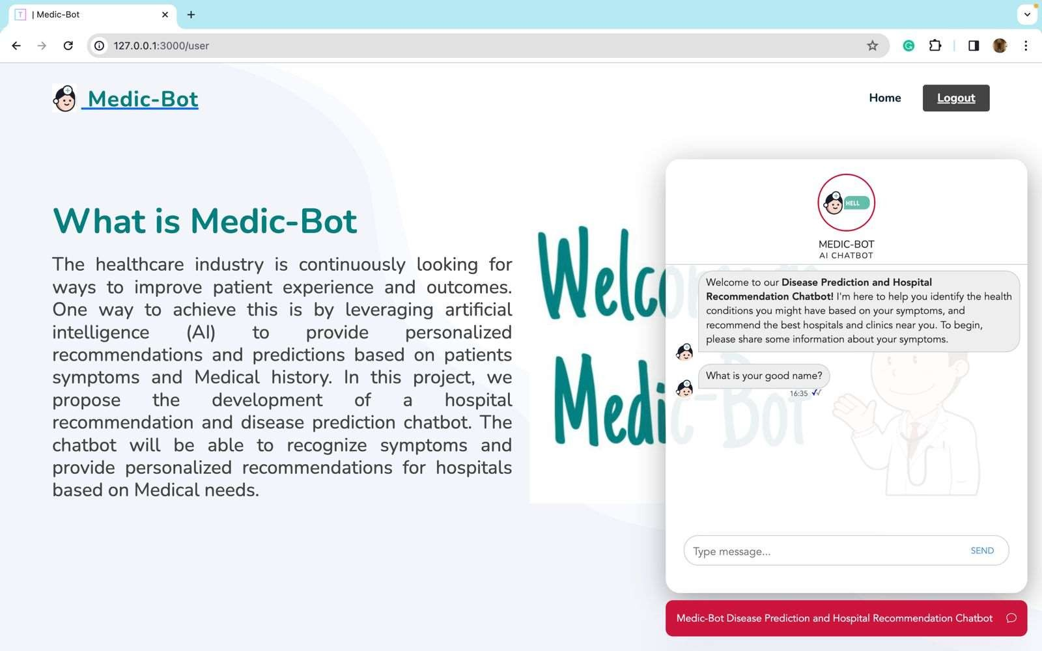

**Figure 9.1.Result1**

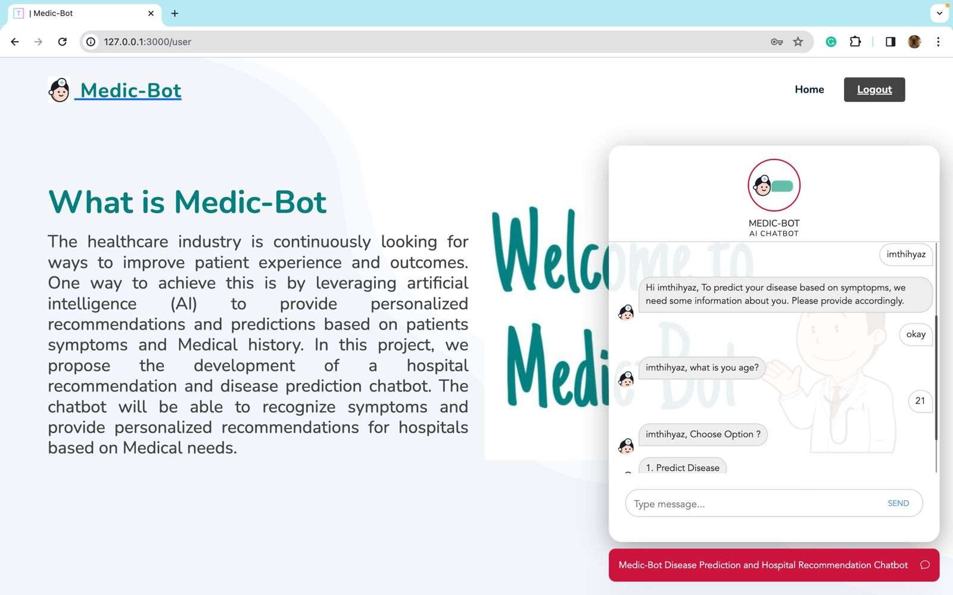

**Figure 9.2.Result2**

# CHAPTER-10 CONCLUSION

In conclusion, the article named "Medic Bot Using Reinforcement" underscores the transformative potential of chatbots in reshaping the landscape of healthcare, offering patients personalized and interactive healthcare experiences. The chatbot system represents a technological stride, leveraging natural language processing (NLP) and machine learning algorithms to decipher user queries and furnish pertinent medical information and recommendations. The distinctive feature of the chatbot's responses lies in their conversational and personalized nature, akin to interactions with a real physician. Integral to its functioning, the chatbot relies on a knowledge base to systematically organize user queries, further harnessing external APIs for NLP to dissect texts, unravel sentence structures, and divulge intricate details about unique words. The document, in its forward-looking perspective, delineates various prospective directions for advancing healthcare-oriented chatbots. These include the integration of more sophisticated machine learning algorithms, the incorporation of voice recognition and speech synthesis technologies, and the exploration of wearable devices to enrich the chatbot's capabilities. The development of chatbots equipped to provide mental health support and counseling, as well as extending multilingual support to cater to patients from diverse linguistic backgrounds. This expansive vision positions the proposed chatbot system as a positive change in healthcare, promising personalized, effective, and inclusive healthcare experiences for patients. The ongoing research in chatbot development within the healthcare domain holds the potential to revolutionize healthcare delivery, ultimately contributing to improved patient outcomes

# REFERENCES

1. Shali, Prashanth, Rishi G, Shriram, Assel, Naskath, (2022)'Bots using Natural Language Processing in Medical Sector' 2022 1st International Conference on Computational Science and Technology (ICCST) | 978-1- 6654- 7655-3/22/$31.00 ©2022 IEEE | DOI: 10.1109/ICCST55948.2022.10040432
2. Santhosham, Prasad Sah C, (2023)'Advanced Healthcare Chat Bot Using Python'2023 2nd International Conference for Innovation in Technology (INOCON) | 979- 8-3503-2092-3/23/$31.00 ©2023 IEEE | DOI: 10.1109/INOCON57975.2023.10101239
3. Syahirah Ahmad N, Hamim Sanusi M, Helmy Abd Wahab M, Mustapha A, Abidin Sayadi Z, Zainuri Saringat M, (2018)'Conversational Bot for Pharmacy:

A Natural Language Approach' in IEEE Xplore

1. Tanmay T, Bhardwaj A, Sharma S, (2020)'E-Health Bot to Change the Face of Medicare' 2020 Research, Innovation, Knowledge Management and Technology Application for Business Sustainability (INBUSH) | 978-1- 7281- 1769-0/20/$31.00 ©2020 IEEE | DOI: 10.1109/INBUSH46973.2020.9392125
2. Goel A, Satyam, Sharma S, (2023)'Artificial Intelligence base Healthcare Chat Bot System'2023 8th International Conference on Communication and Electronics Systems (ICCES) | 979-8-3503-9663- 8/23/$31.00 ©2023 IEEE | DOI: 10.1109/ICCES57224.2023.10192727
3. Srivastava P, Singh N, (2020)'Automatized Medical Chatbot (Medibot)'2020 International Conference on Power Electronics & IoT Applications in Renewable Energy and its Control (PARC) 978-1-7281-6575-2/20/$31.00

©2020 IEEE 10.1109/PARC49193.2020.236624

1. Athulya N, Jeeshna K, S J Aadithyan, U Sreelakshmi, Hairunizha Alias Nisha Rose, (2021)'Healthcare Chatbot'9(10) | ISSN: 2320-2882
2. Alvarez J, Campos G, Enriquez V, Miranda A, Rodriguez F, Ponce H, (2018)'Nurse-Bot: A Robot System Applied to Medical Assistance'2018 International Conference on Mechatronics, Electronics and Automotive Engineering (ICMEAE)
3. R Jegadeesan, Dava Srinivas, N Umapathi, G Karthick, N Venkateswaran (2023)'Personal Healthcare Chatbot for Medical suggestions using Artificial Intelligence and Machine Learning ‘Section A-Research paper
4. Shuyang Li, Prasad Majumder B, McAuley J, (2021)'Self-Supervised Bot play for Conversational Recommendation with Justifications'arXiv:2112.05197v1 [cs.CL] 9 Dec 2021
5. Dyyak I, Melnyk B, Melnyk N, Trokhaniak S, Drakohrust T, Svitlak I, (2021)'Using an Internet Bot to Predict the Spread of COVID-19'2021 11th International Conference on Advanced Computer Information Technologies (ACIT) | 978-1-6654-1854-6/21/$31.00 ©2021 IEEE | DOI: 10.1109/ACIT52158.2021.9548345
6. Reshmanth P, Sushanth Chowdary p, Yogitha R, Aishwarya R, (2022)'Deployment of Medibot in Medical Field'2022 International Conference on Sustainable Computing and Data Communication Systems (ICSCDS) | 978- 1-6654-7884-7/22/$31.00 ©2022 IEEE |DOI:

10.1109/ICSCDS53736.2022.9760900Dobbie, U. Frank, G. Kappel, S. W.

Liddle, and H. C. Mayr, Eds. Cham, Switzerland: Springer, 2020, pp. 207–222

# APPENDIX-A PSUEDOCODE

# Pseudocode for the Self-Learning Medic Bot Application

1. Initialize the Flask application and set up database models.
2. Define a function to create a cryptographically secure token for user sessions.
3. Create a user model with fields for id, username, email, and password.
4. Define routes for:
   1. Home page ("/") - Display the main page.
   2. User authentication ("/user") - Authenticate users and generate a session token.
   3. Instruction page ("/instruct") - Display instructions or information.
   4. BMI page ("/upload") - Display a page related to BMI.
   5. Diseases page ("/diseases") - Display information related to diseases.
5. Implement a login route ("/login") to authenticate users using the User model.
6. Implement a registration route ("/register") to allow users to register and store their information in the database.
7. Import necessary libraries and modules for the chatbot and disease prediction.
8. Create routes for the chatbot interaction:
   1. "/" - Display the main page.
   2. "/ask" - Process user messages and provide appropriate responses based on the chatbot's state.
9. Define functions for predicting symptoms and diseases using machine learning models.
10. Implement routes for disease prediction ("/pred_page") and user interaction ("/chat_msg").
11. Run the Flask application with database creation. # End of Pseudocode

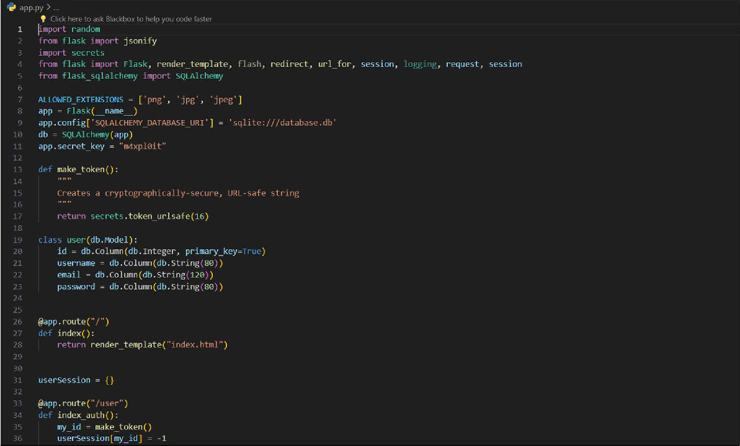

**Psuedocode1**

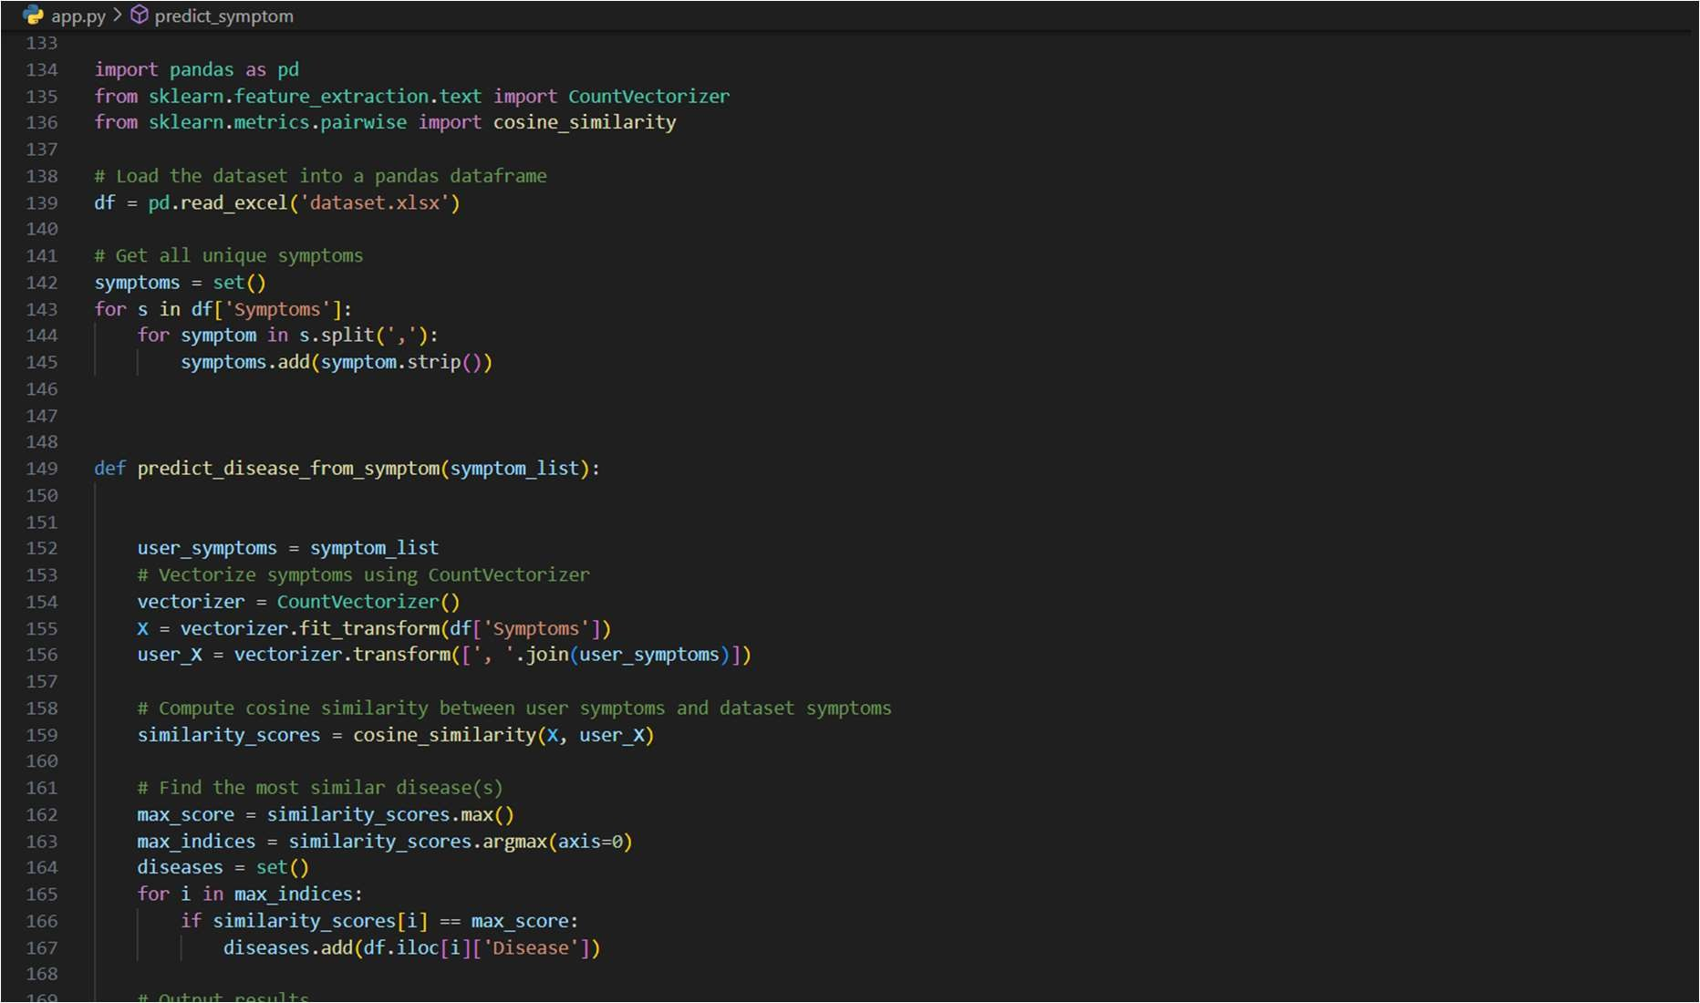

**Psuedocode2**

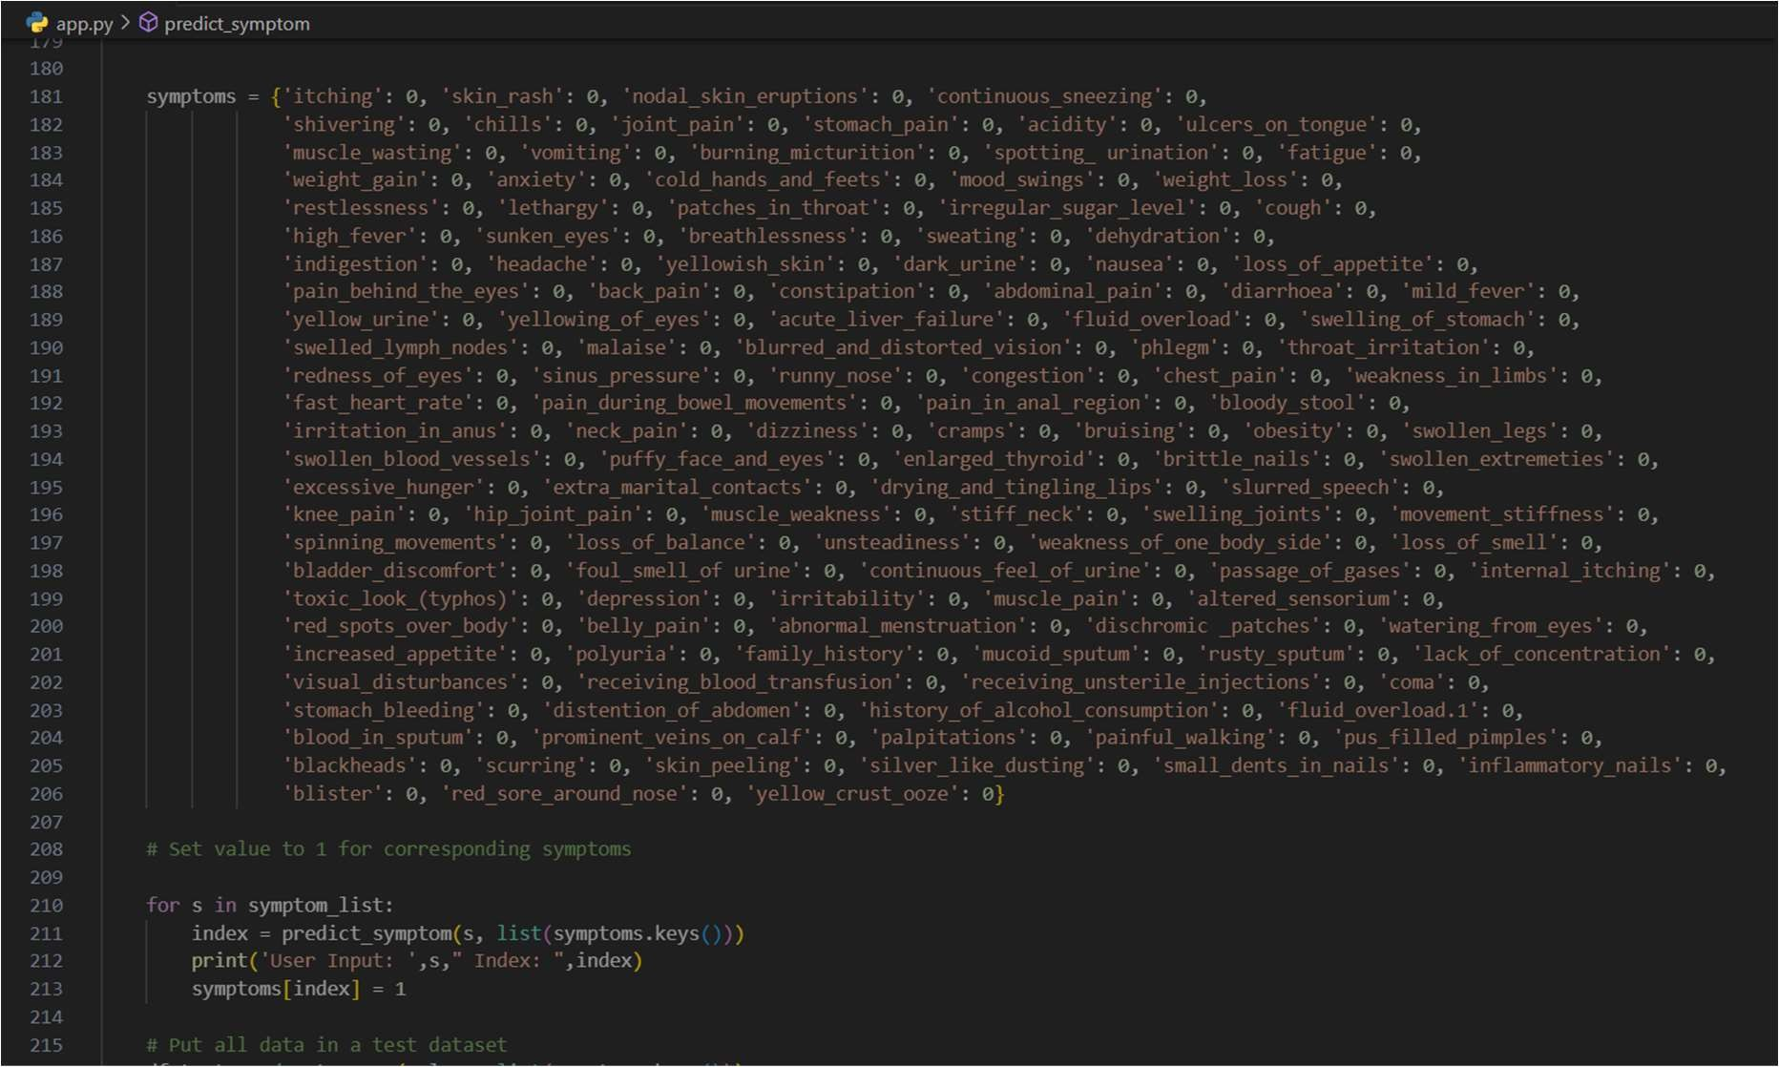

**Psuedocode3**

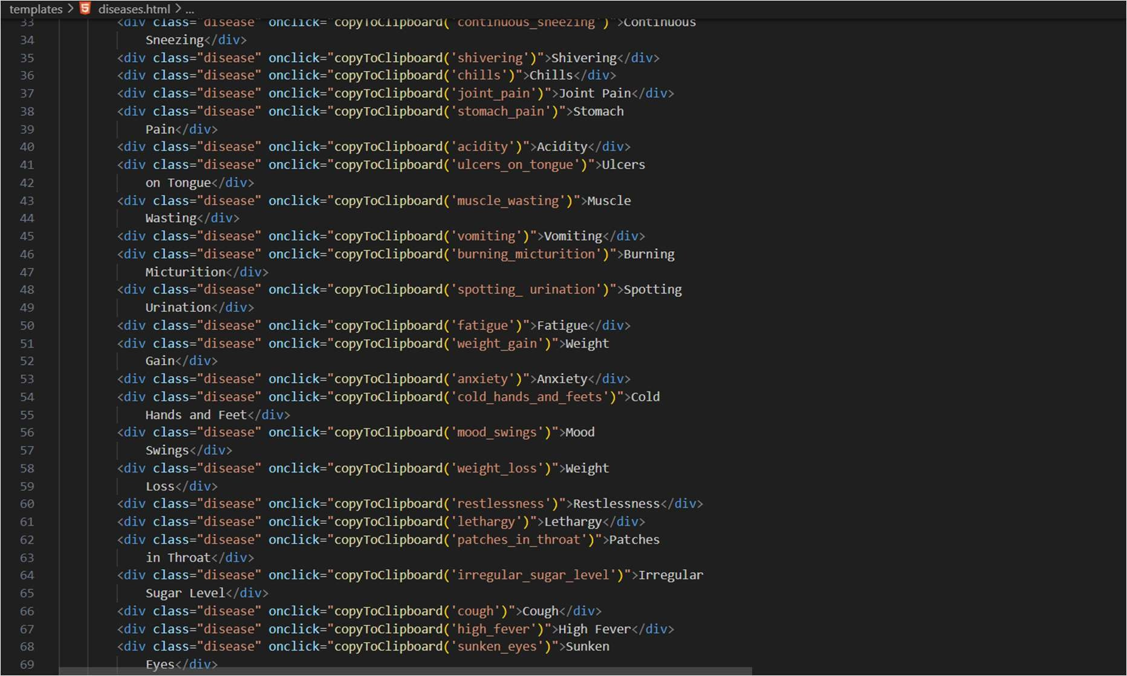

**Psuedocode4**

# APPENDIX-B SCREENSHOTS

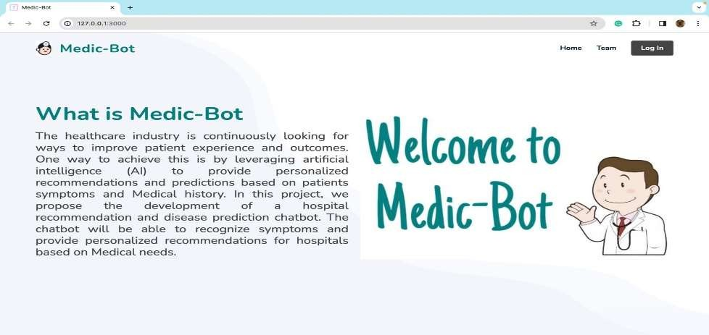

**Figure11.1. Home Page**

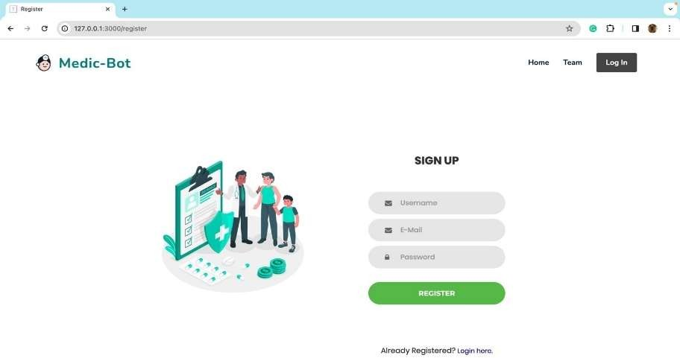

**Figure11.2. Register Page**

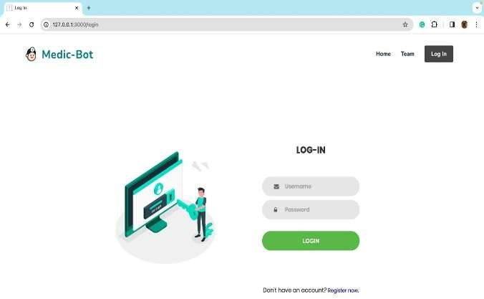

**Figure 11.3. Login Page**

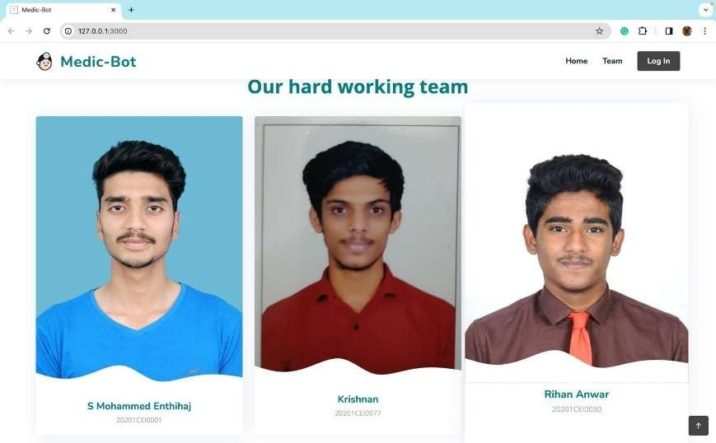

**Figure 11.4. AboutPage1**

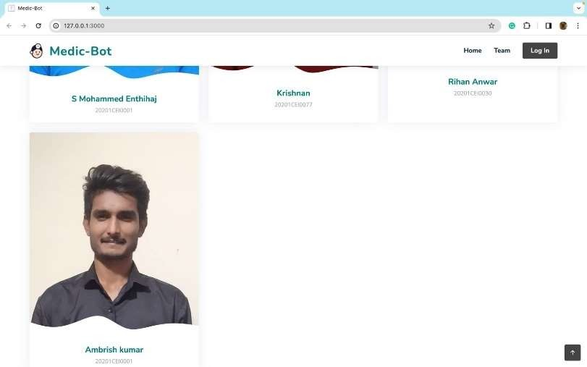

**Figure 11.5. InfoPage2**



**Figure 11.7. Result Page**

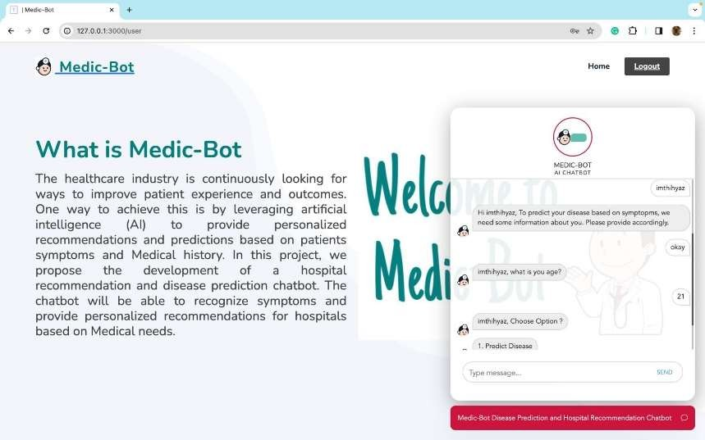

**Fig.11.7. Result2**

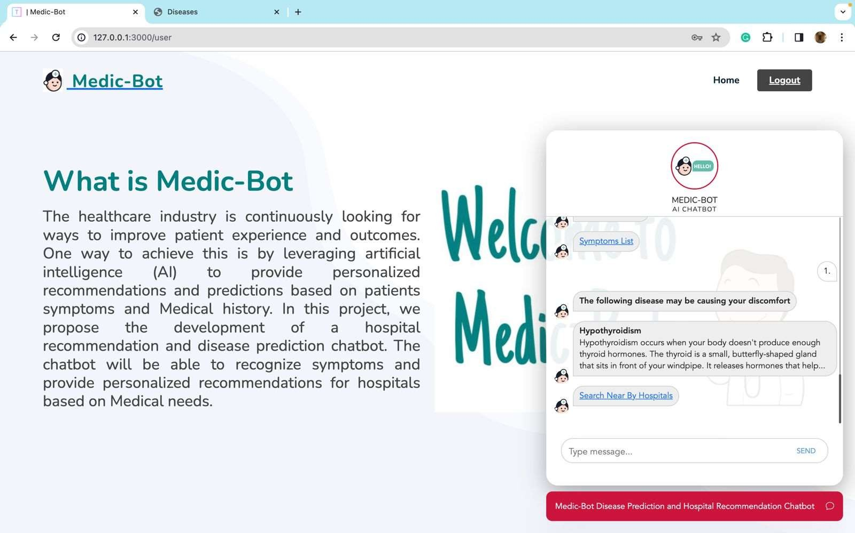

**Fig.11.8. Result3**

# APPENDIX-C ENCLOSURES

1. **Conference Paper Presented Certificates of all students.**

**2.Similarity Index / Plagiarism Check report.**

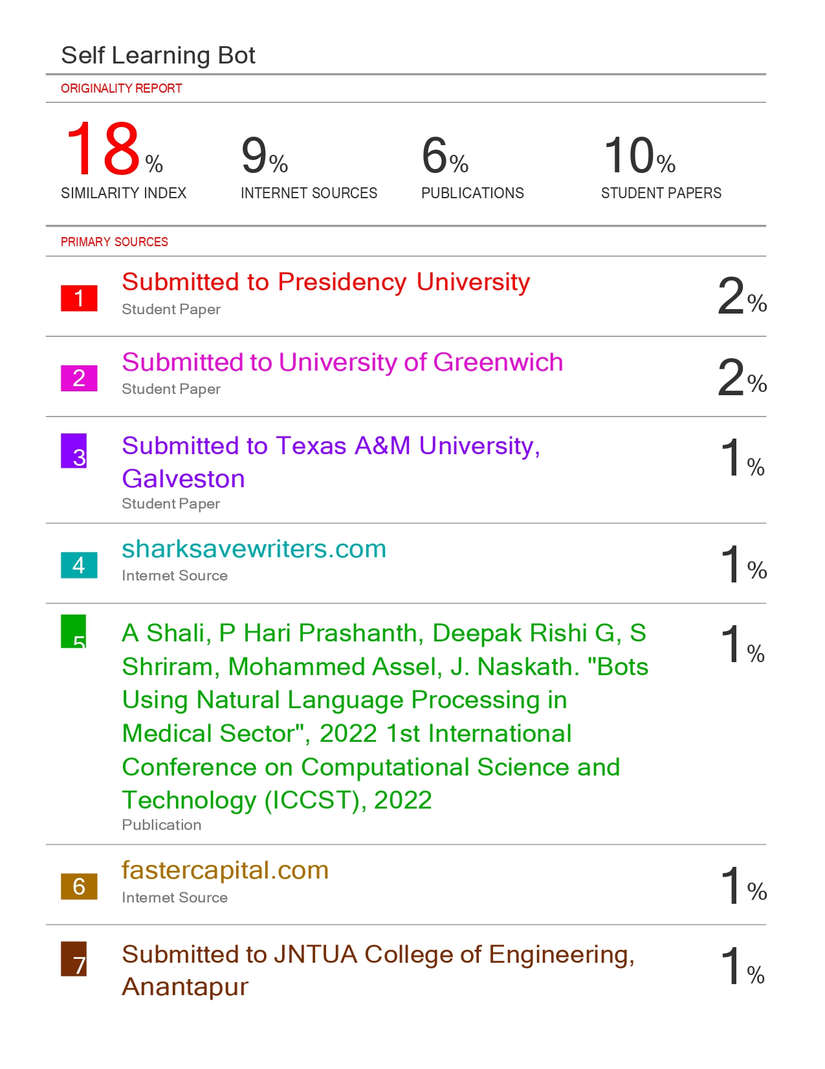

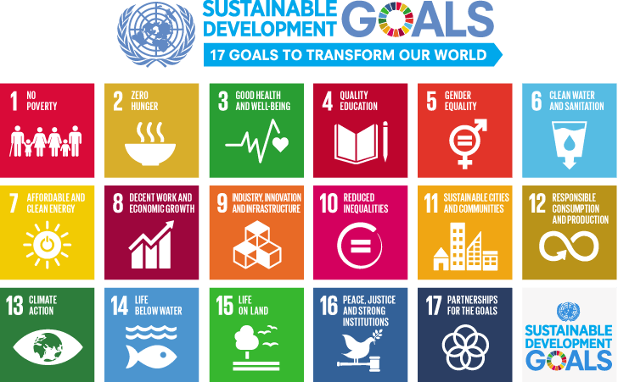

The Self-learning Medic Bot project aligns with the United Nations Sustainable Development Goal (SDG) 3: Good Health and Well-being. By leveraging artificial intelligence and self-learning capabilities, the project aims to provide accessible and personalized healthcare information, promoting health literacy and empowering individuals to make informed decisions about their well-being. This initiative contributes to the broader global agenda of ensuring healthy lives and promoting well-being for all at all ages**.**